VCS Task

Establish a new directory, populate it with script files, initiate an empty repository on GitHub, convert the local directory into a Git repository, and link it to GitHub for pushing the code into the repository.Perform merge, rebase, stash commands in following github repo.

1. Create a New Directory
- Open Git bash in windows
- Go to the location
- mkdir My-first-project
- cd My-first-project
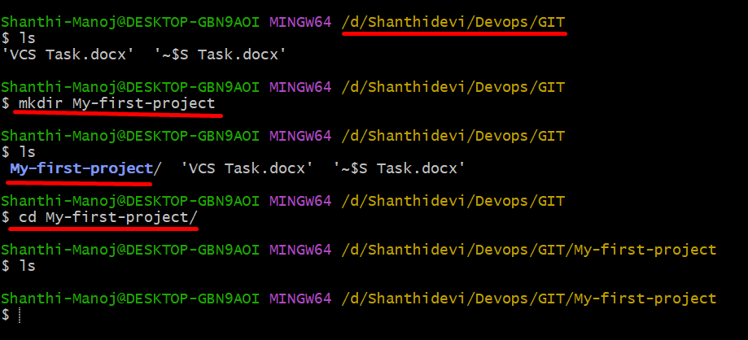
2. Create Script Files
- In bash create 2 script files
- Put this commands :
- $ echo "echo Hello this is my first script file in GIthub" > script1.sh
- $ echo "echo Learning Githib and created the second file" > script2.sh
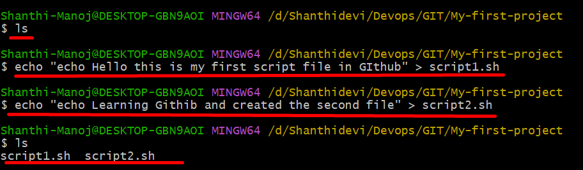
3. Initialize Git Repository
# git init
# ls -la
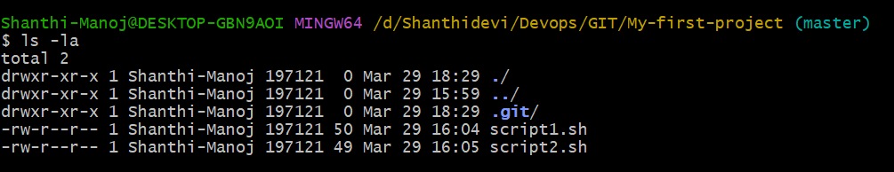
4. Add and Commit Files
# git add .
# git commit -m "Added commit with script files"
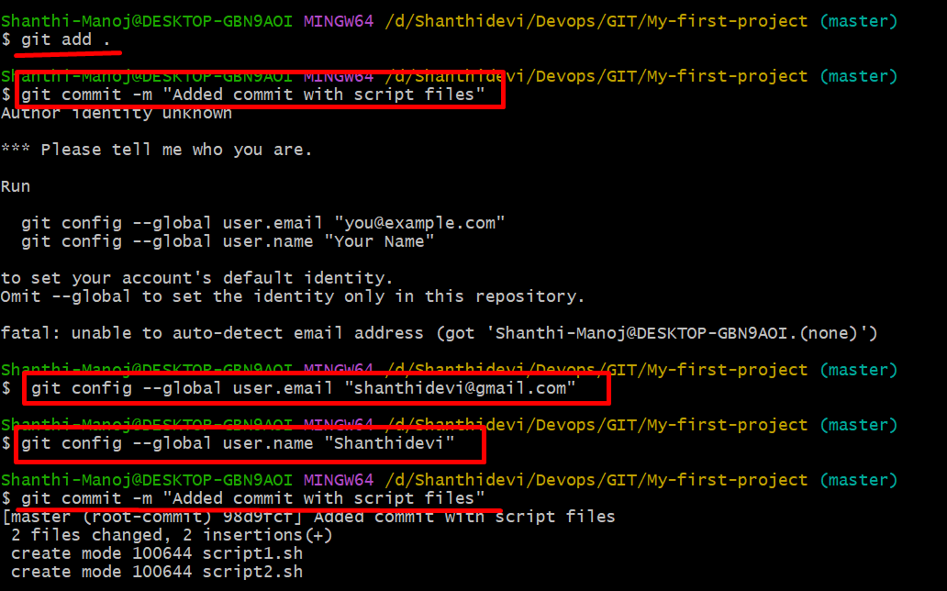
5.Create Repository on GitHub
Go to GitHub and:
- Click New Repository
- Enter repository name my-first-git-project
- Click Create Repository
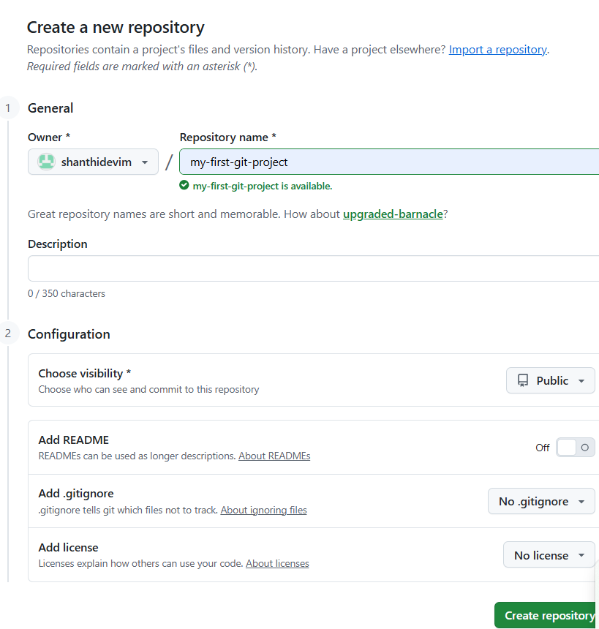
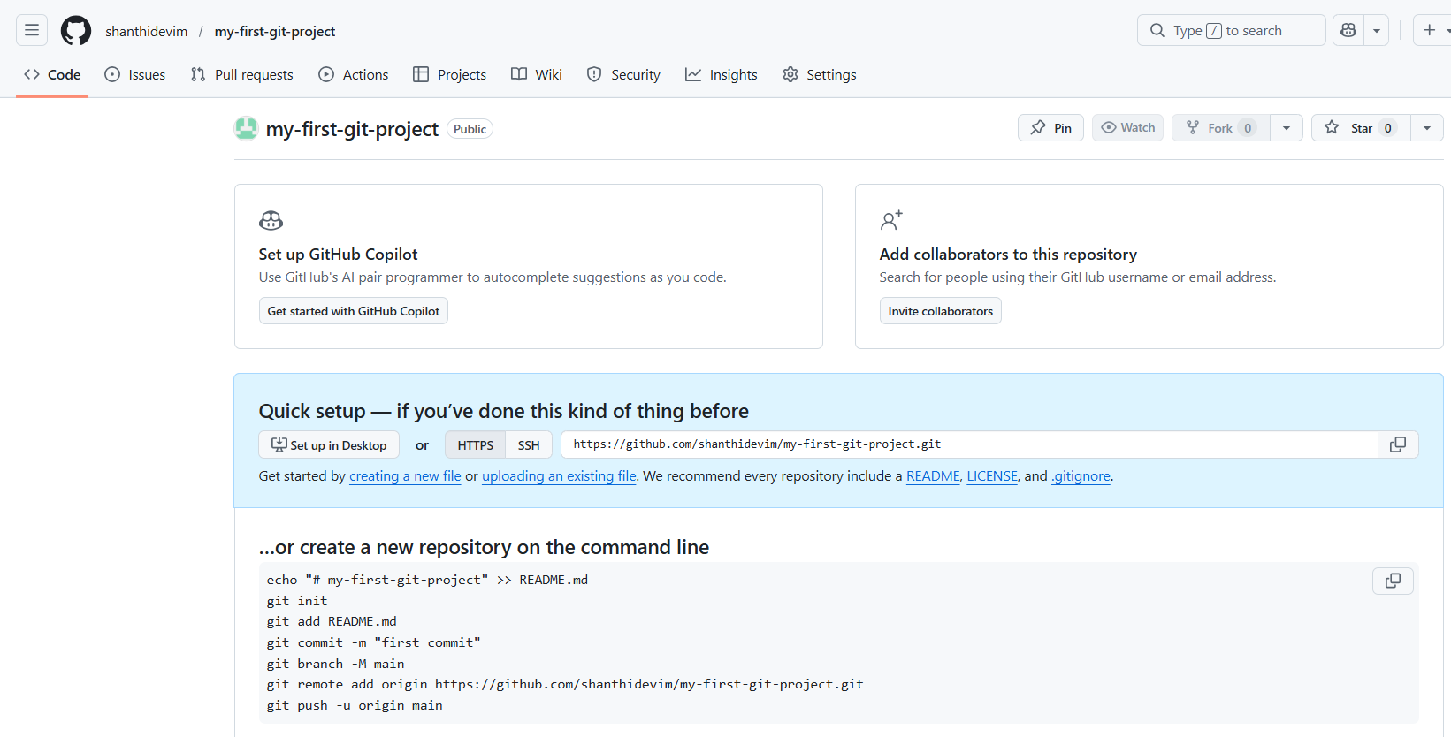
6. Link Local Repo to GitHub
# git remote add origin https://github.com/shanthidevim/my-first-git-project.git
# git branch -M main
# git push -u origin main

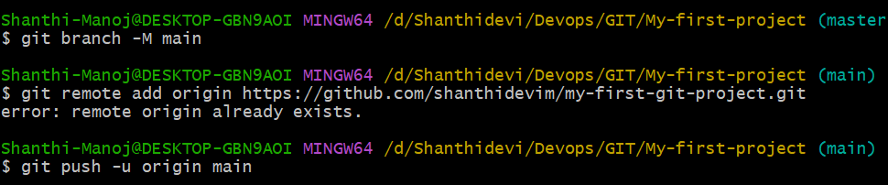
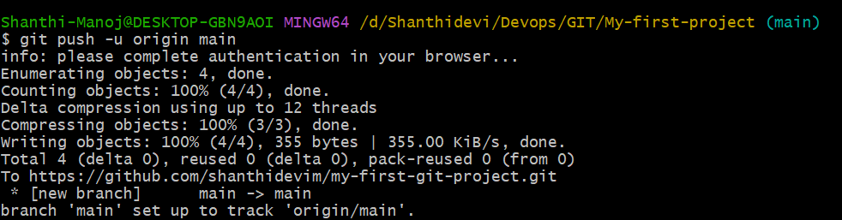

7. Git Operations
7.1 Branch Creation:
# git checkout -b shanthi-cicd
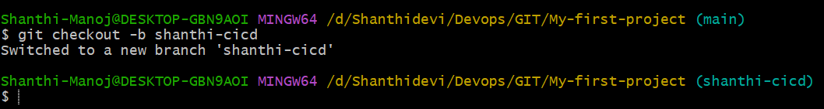
7.2. Make Changes
# echo "Added the new content for merge" >> script1.sh
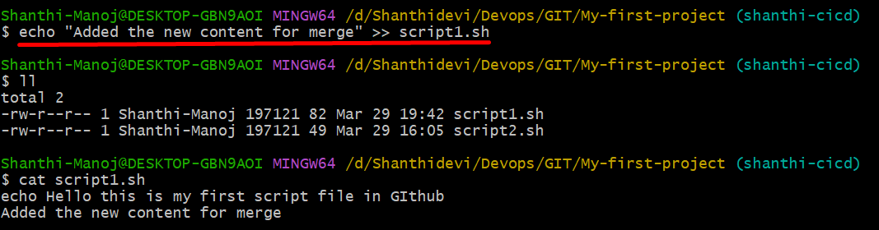
# git add .
# git commit -m "Added new content"
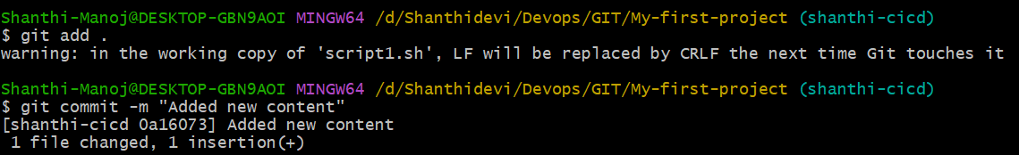

7.3. Merge Operation
# git checkout main
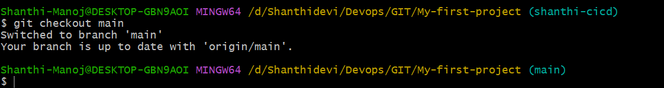
# git merge shanthi-cicd
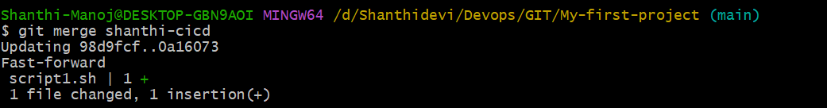
7.4. Rebase Operation
Description:
- Rebase moves commits from one branch on top of another
- Creates linear history (clean)
# git checkout -b rebase-cicd
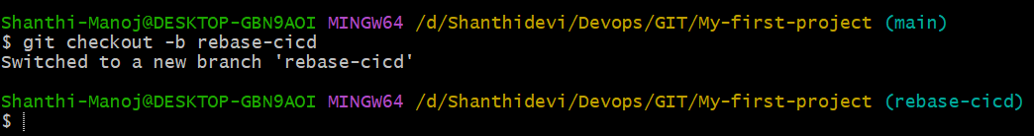
# echo "Rebase new content" >> script2.sh 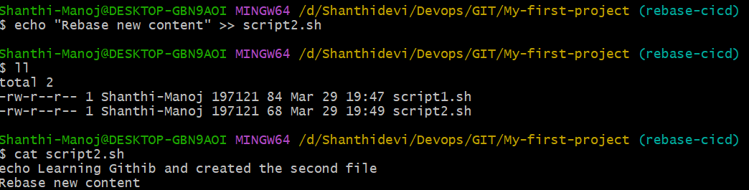
# git add .
# git commit -m "Added the new Rebase changes"
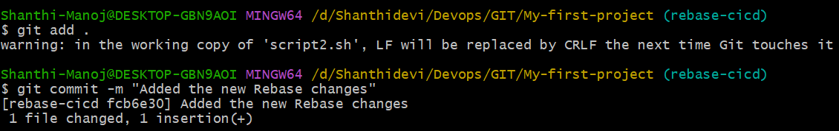
# git checkout main
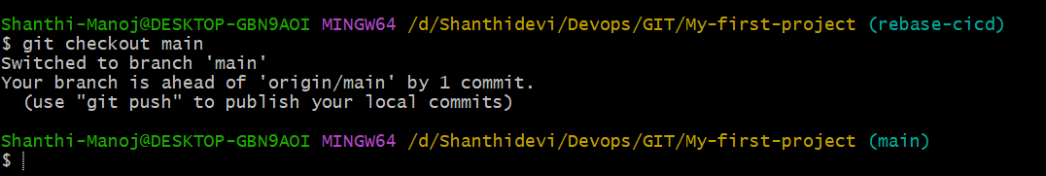
# git rebase rebase-cicd
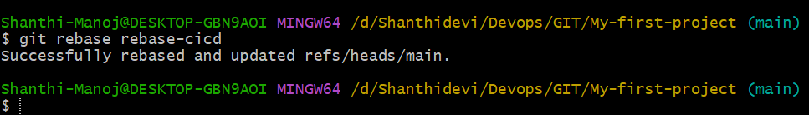
Difference Between Merge & Rebase
Merge | Rebase
Keeps history as-is | Rewrites history
Creates merge commit | No extra commit
Safe for shared branches | Risky if already pushed

7.5. Stash Operation
Description:
- Saves temporary changes without committing
- Cleans working directory
- Useful when switching tasks quickly
# echo "Temporary change for stash" >> script1.sh
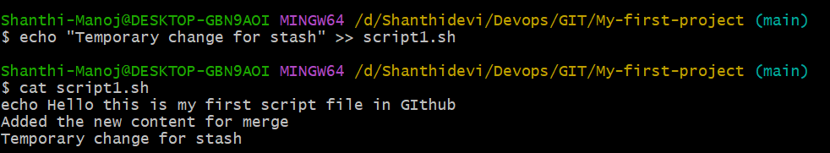
# git stash
Check Stash:
# git stash list
Apply Stash:
# git stash apply
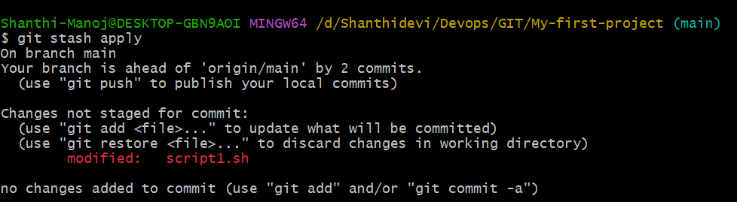
Delete Stash:
# git stash drop

7.6 Push Final Changes
# git push origin main
